Contacting Contributors

I kept in regular contact with both Alan Tamblyn and Chris Lawton around the time of organising their interviews, however I kept in regular contact with Amie Slavin throughout the whole process of the project. Here are several examples of the emails I sent to each contributor.

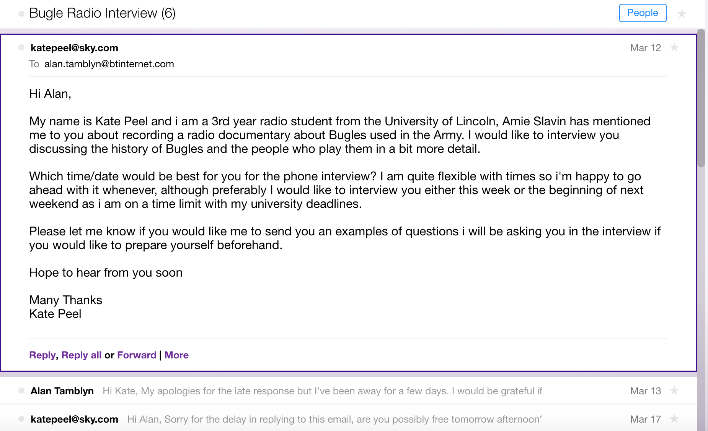
Emails with Alan Tamblyn

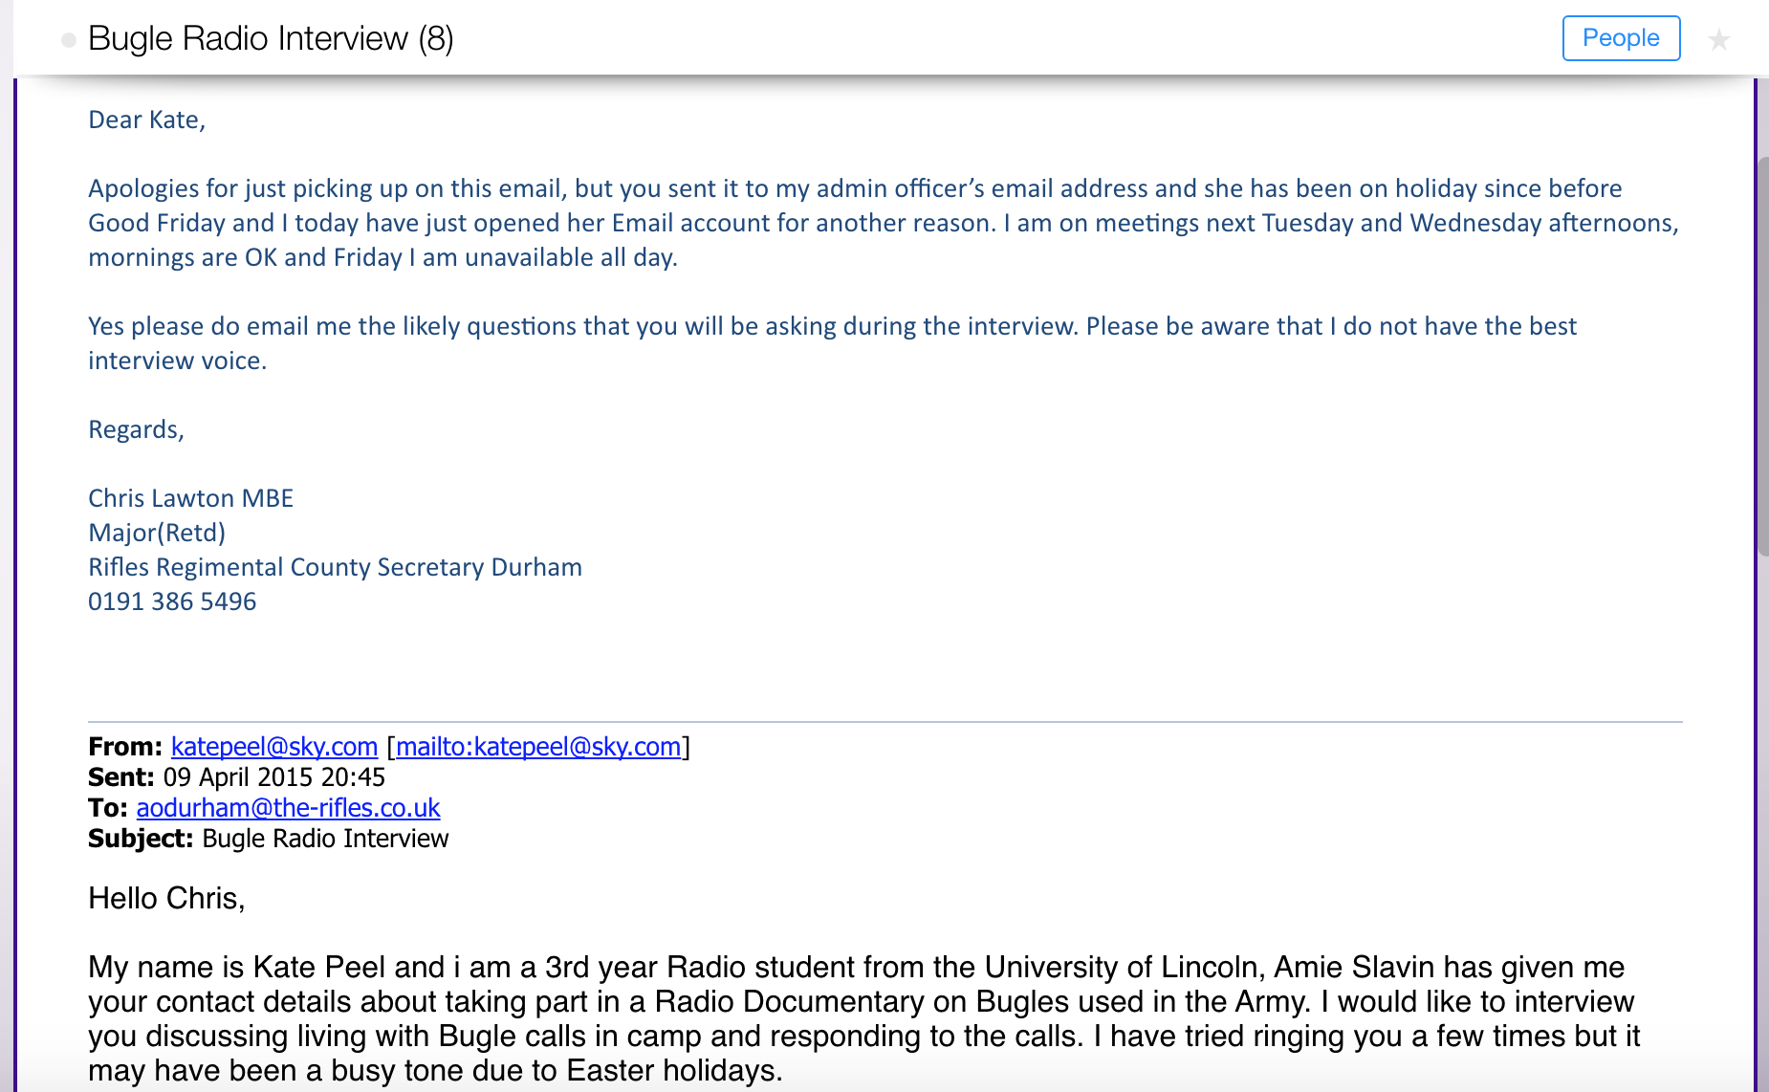
Emails with Chris Lawton
Emails with Amie Slavin

